Probability-Answers
Key Stage 3: 2003 Paper 1 Level 5-7
1.
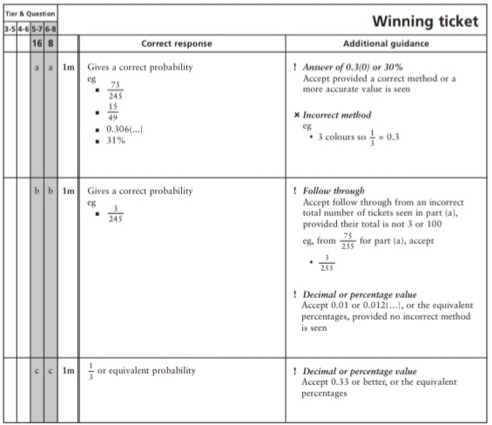
Key Stage 3: 2003 Paper 2 Level 5-7
2.
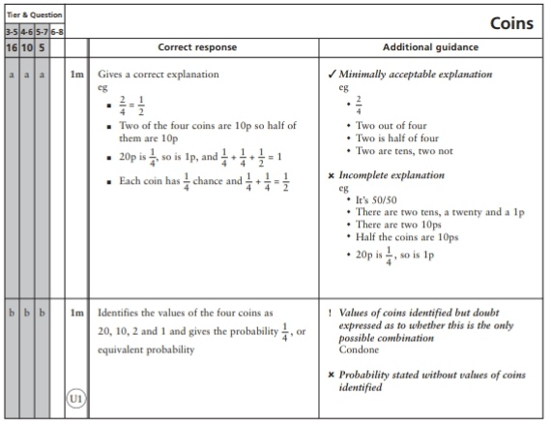
Key Stage 3: 2003 Paper 1 Level 6-8
3.
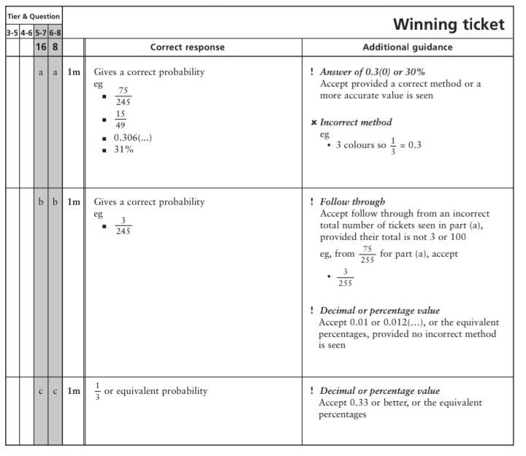
4.
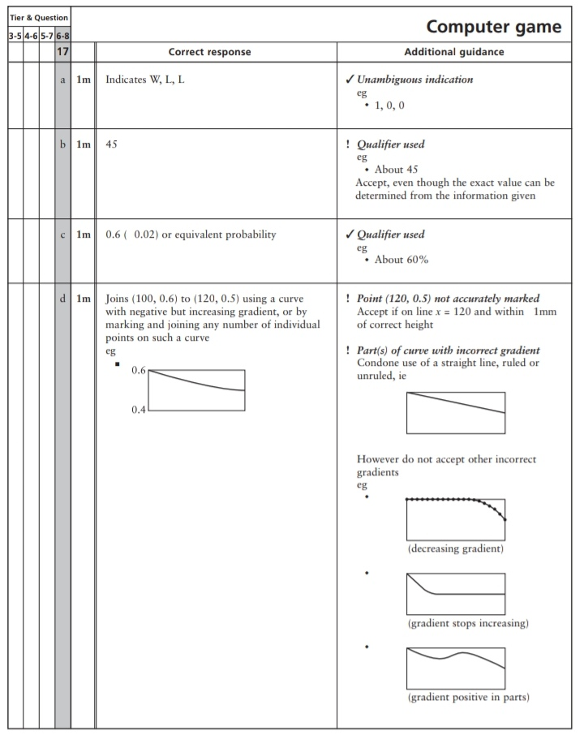
Key Stage 3: 2004 Paper 1 Level 5-7
5.
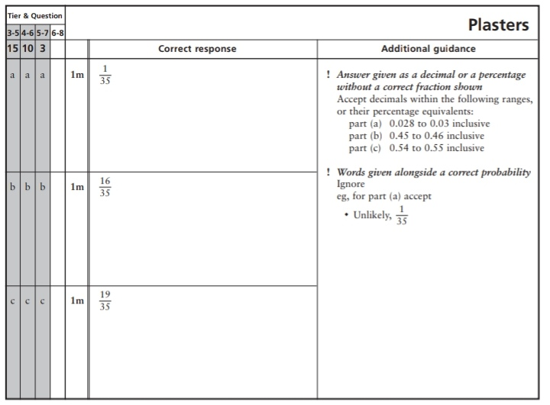
6.
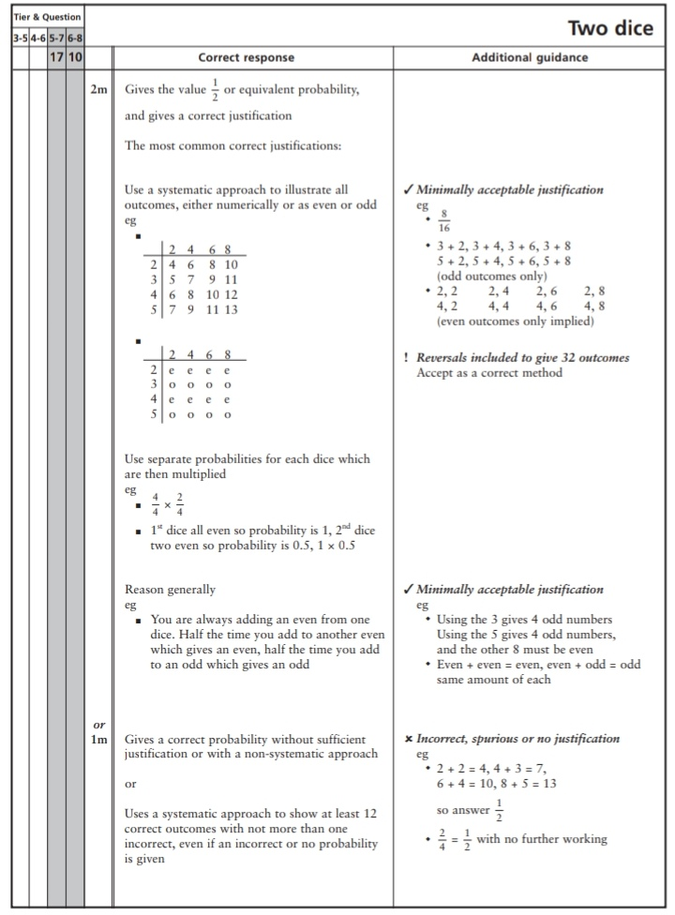
Key Stage 3: 2004 Paper 1 Level 6-8
7.
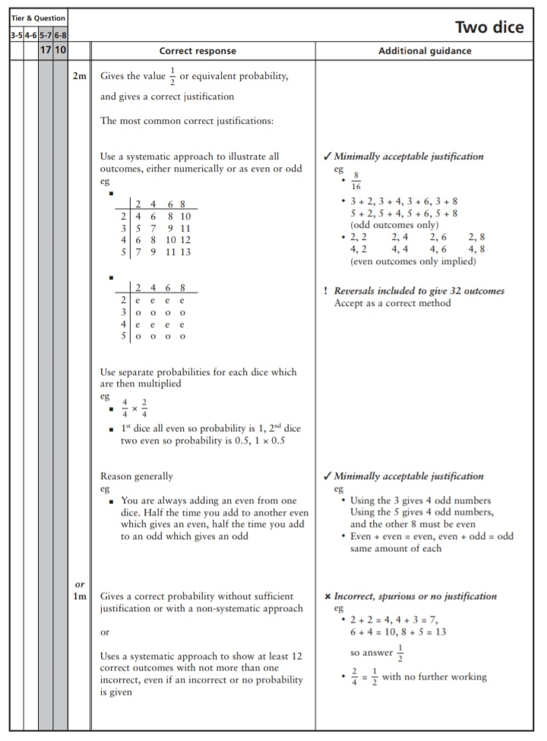
Key Stage 3: 2005 Paper 1 Level 5-7
8.
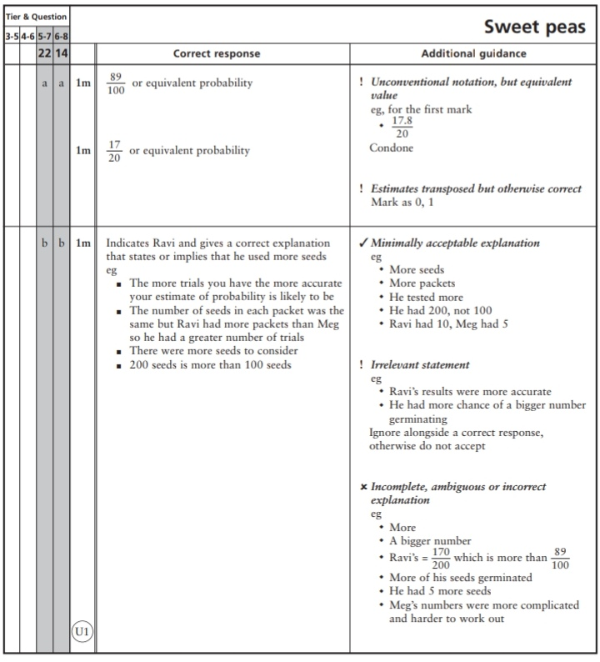
Key Stage 3: 2005 Paper 2 Level 5-7
9.
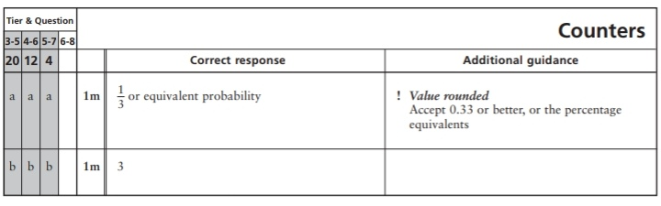
10.
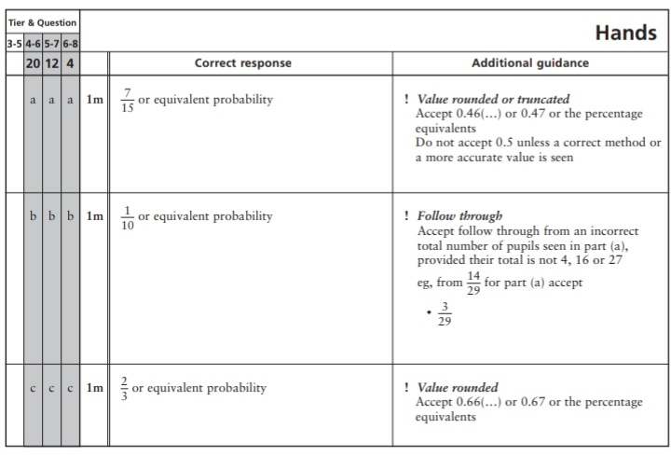
11.
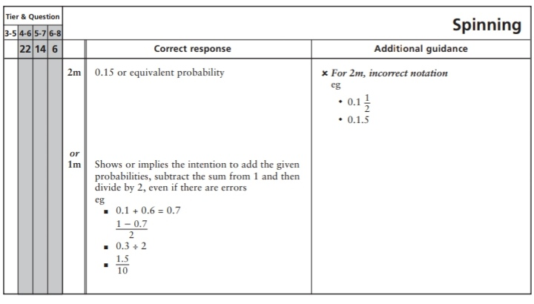
Key Stage 3: 2005 Paper 2 Level 6-8
12.
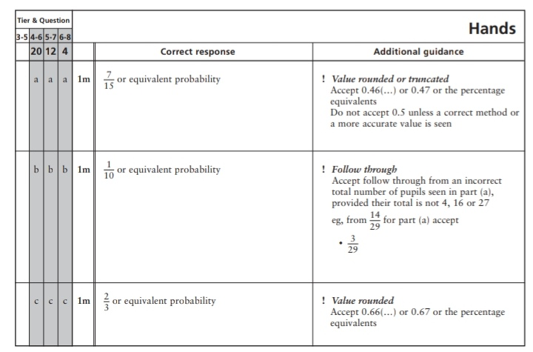
13.
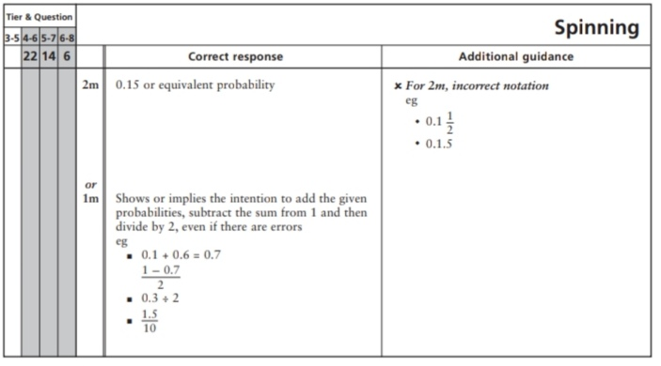
Key Stage 3: 2006 Paper 2 Level 5-7
14.
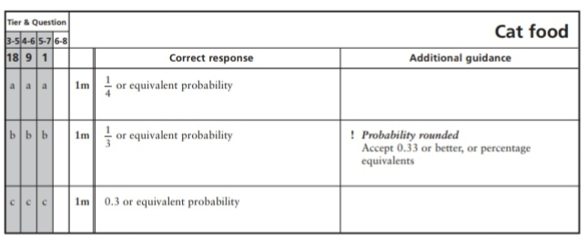
15.
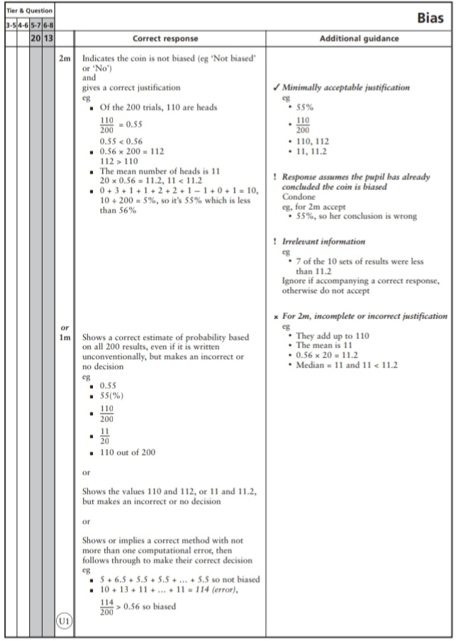
16.
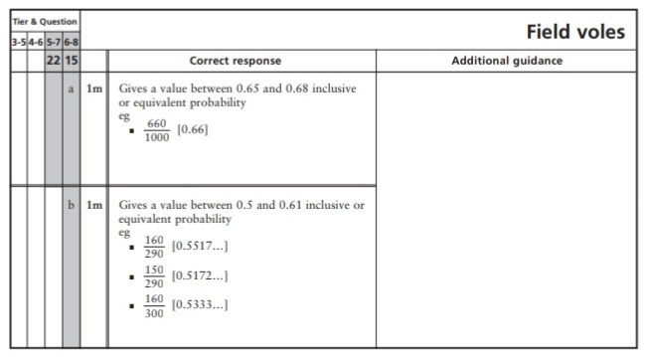
Key Stage 3: 2006 Paper 2 Level 6-8
17.
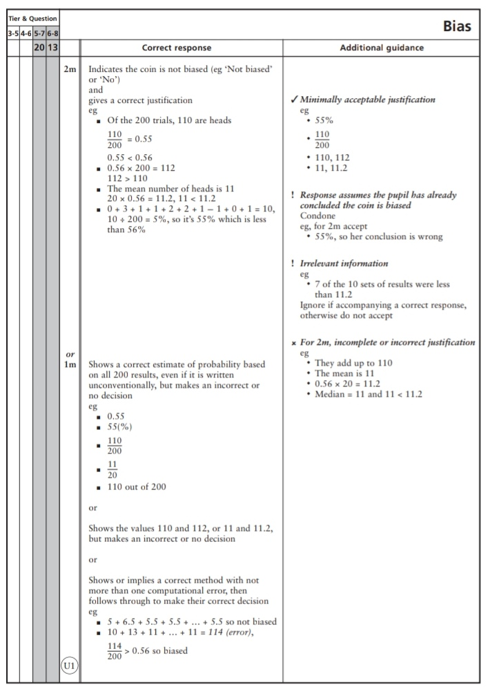
18.
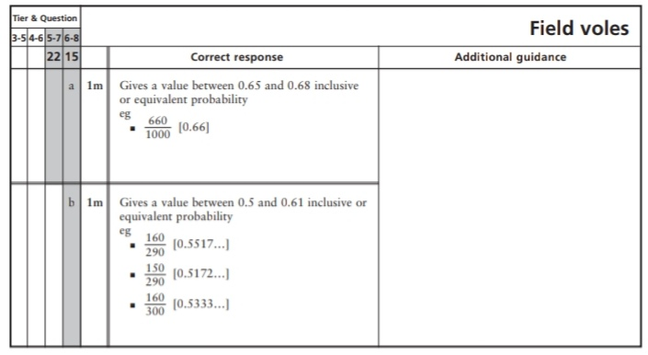
19.
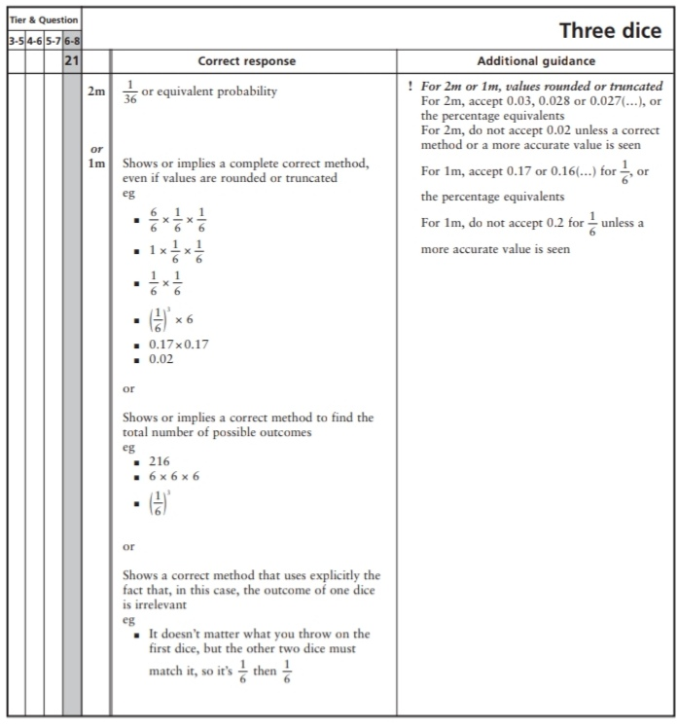
Key Stage 3: 2007 Paper 1 Level 5-7
20.
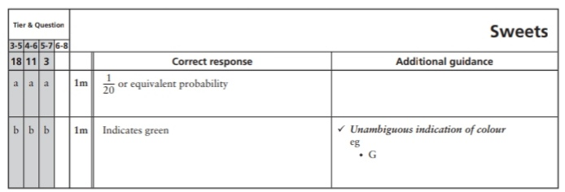
21.
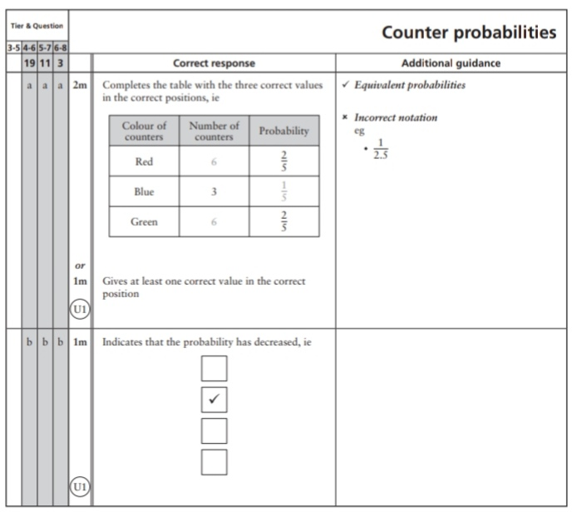
22.
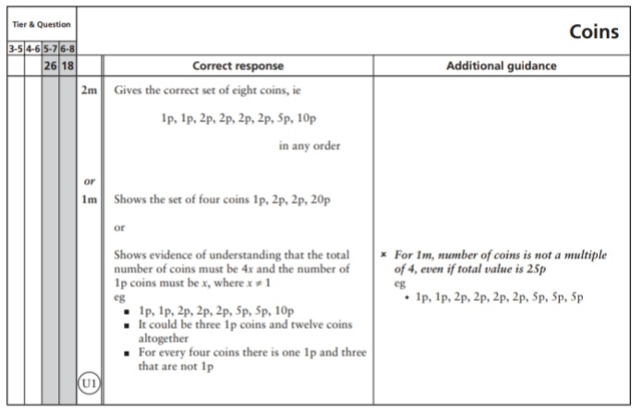
Key Stage 3: 2007 Paper 2 Level 5-7
23.
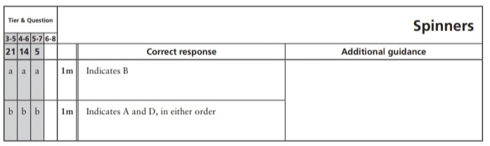
24.
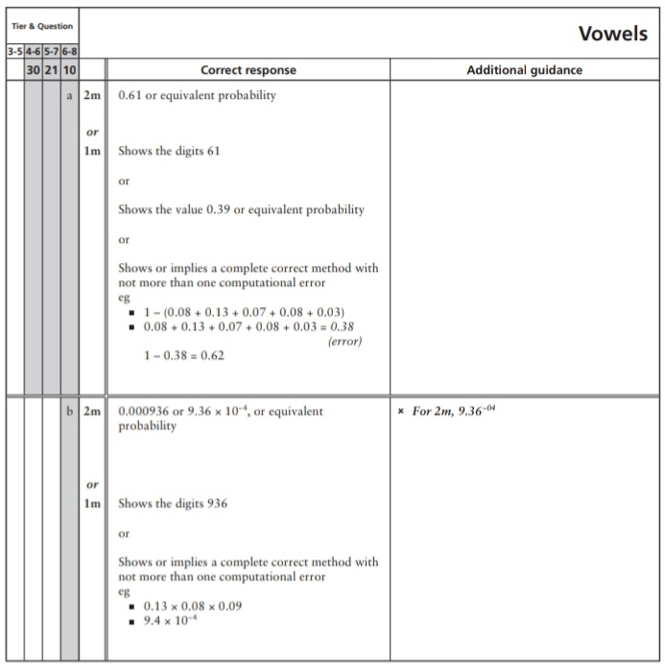
25.
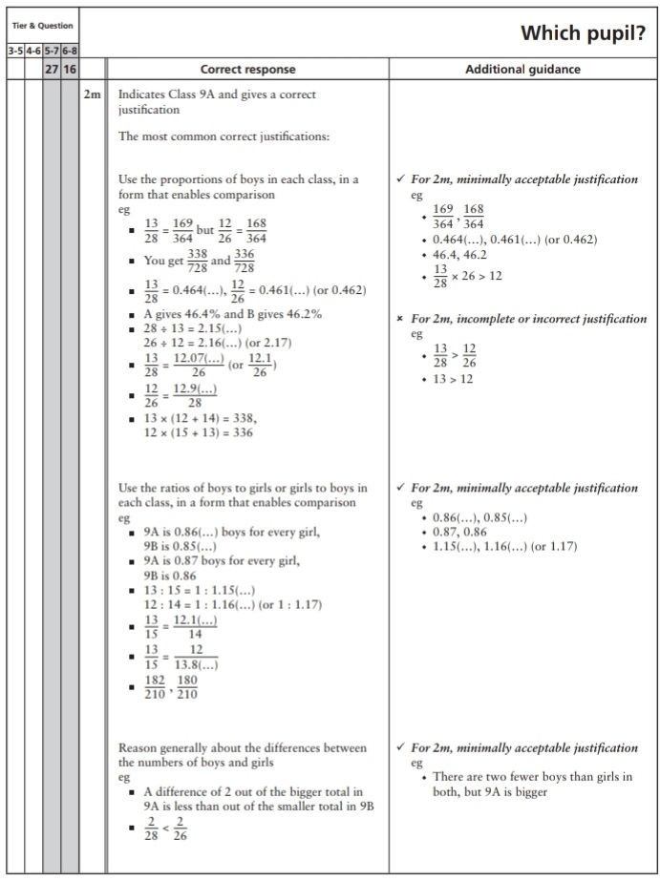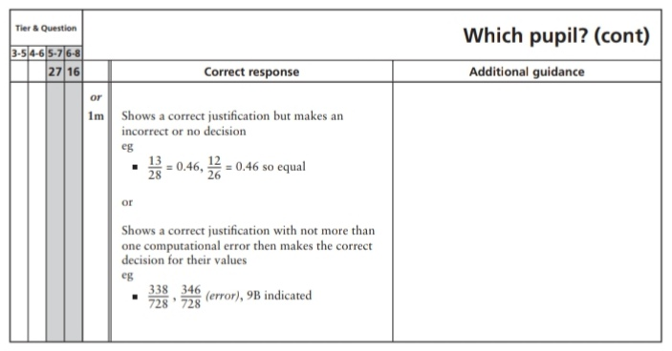
Key Stage 3: 2007 Paper 1 Level 6-8
26.
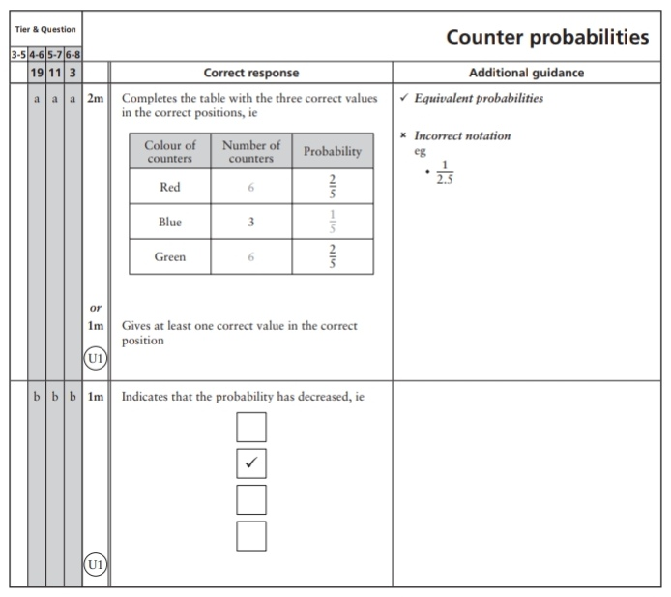
27.
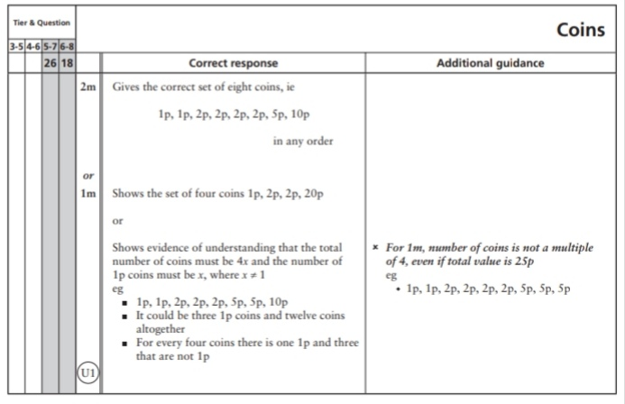
Key Stage 3: 2007 Paper 2 Level 6-8
28.
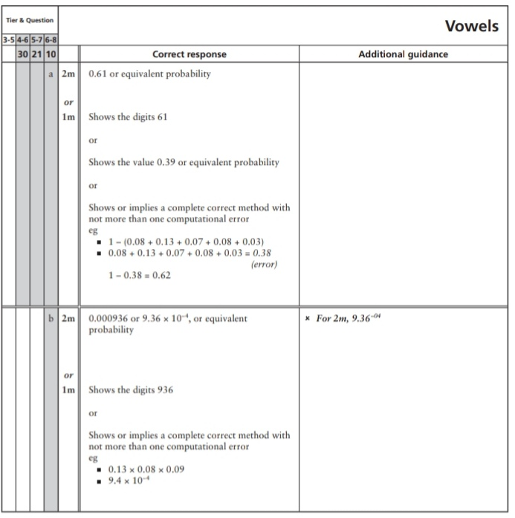
29.
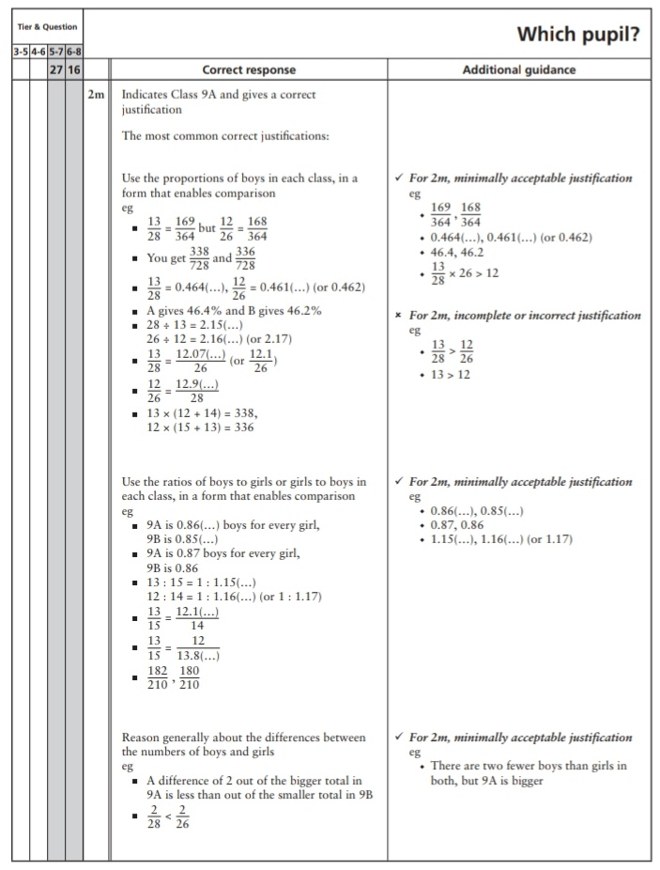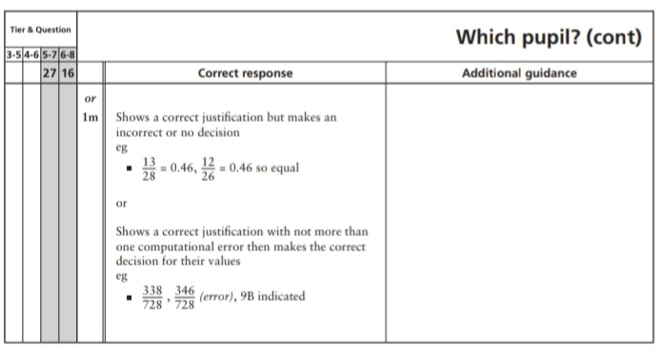
Key Stage 3: 2008 Paper 1 Level 5-7
30.
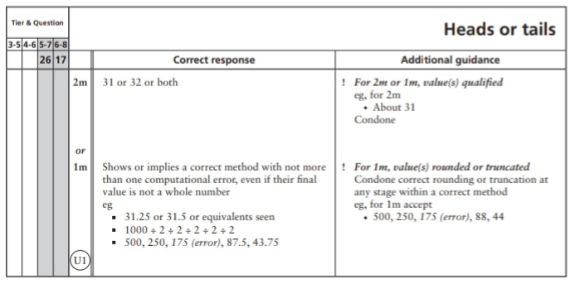
Key Stage 3: 2008 Paper 2 Level 5-7
31.
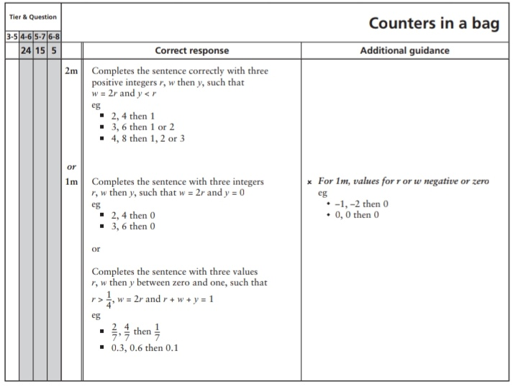
Key Stage 3: 2008 Paper 1 Level 6-8
32.
33.
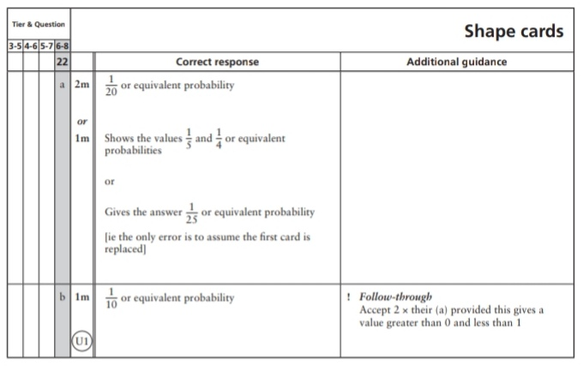
Key Stage 3: 2008 Paper 2 Level 6-8
34.
Key Stage 3: 2009 Paper 1 Level 5-7
35.
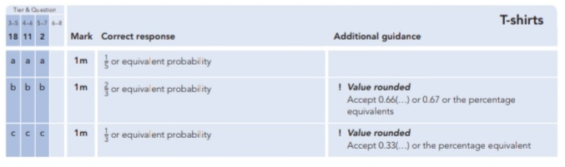
Key Stage 3: 2009 Paper 2 Level 5-7
36.
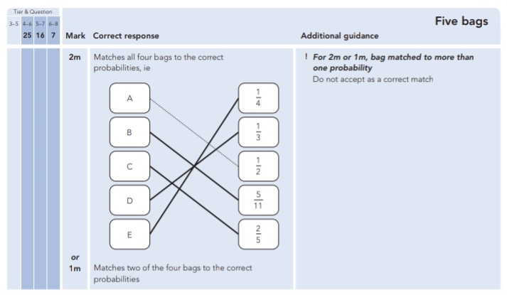
Key Stage 3: 2009 Paper 1 Level 6-8
37.
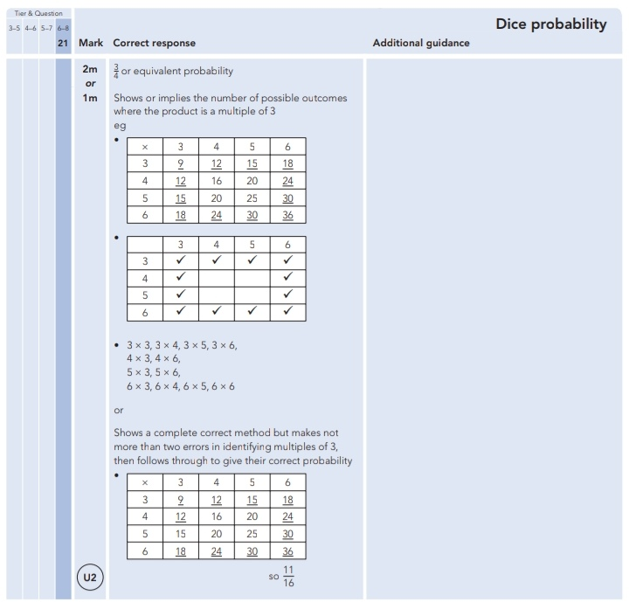
Key Stage 3: 2009 Paper 2 Level 6-8
38.
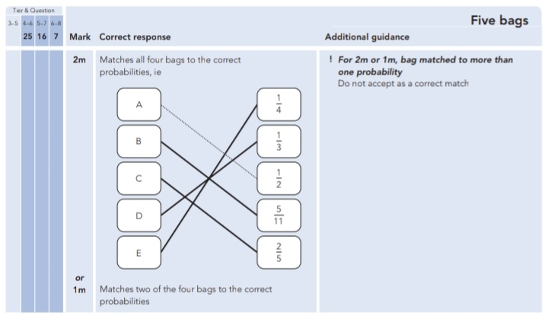
Key Stage 3: 2010 Paper 1 Level 5-7
39.
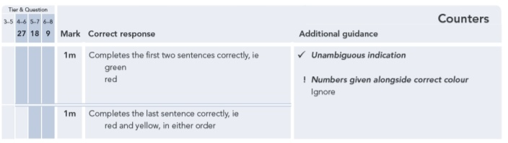
Key Stage 3: 2010 Paper 2 Level 5-7
40.
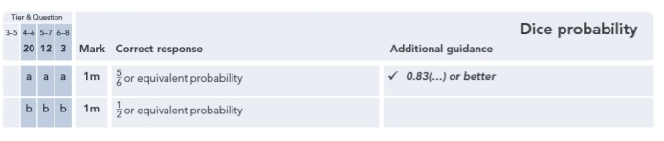
Key Stage 3: 2010 Paper 1 Level 6-8
41.
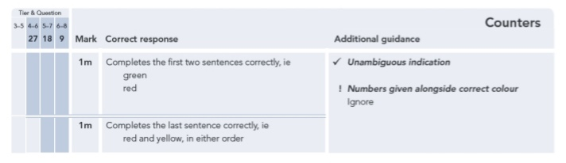
42.
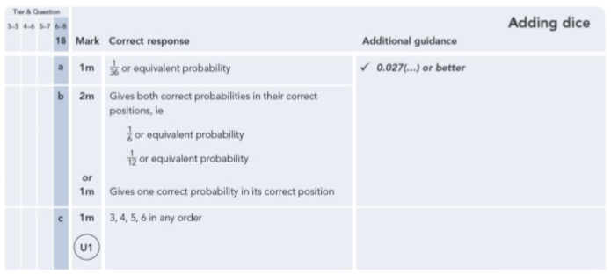
43.
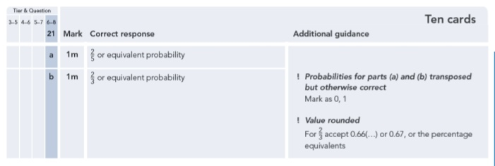
Key Stage 3: 2010 Paper 2 Level 6-8
44.
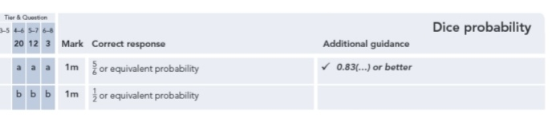
Key Stage 3: 2011 Paper 1 Level 5-7
45.
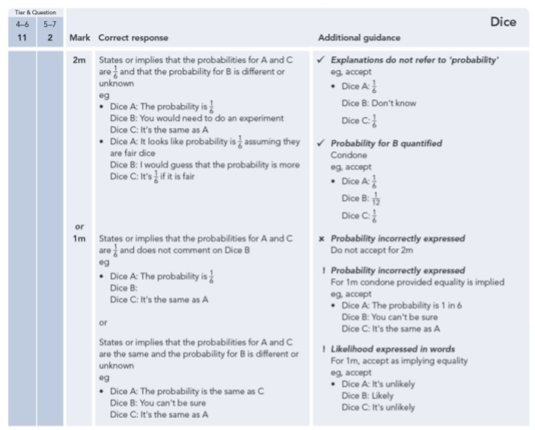
46.
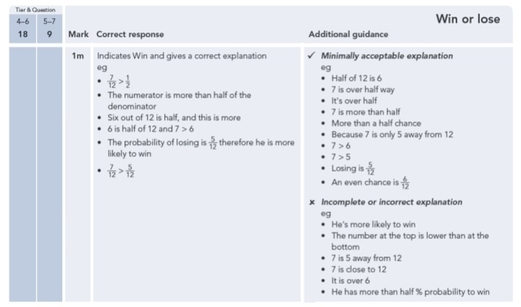
47.
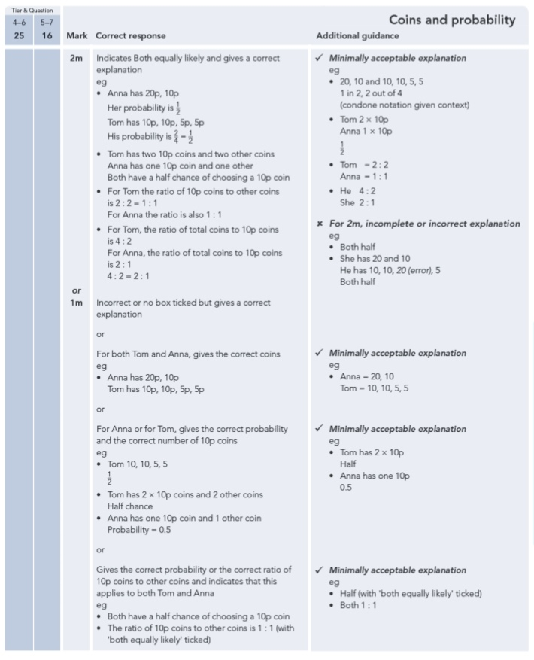
Key Stage 3: 2011 Paper 2 Level 5-7
48.
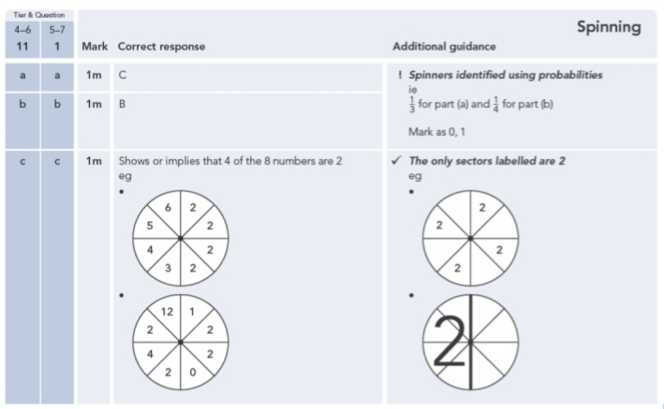
49.
